ModeloClasesySecuencias
Sequence Diagram
Author: Author
Revision: 0.2

No Magic
One Allen Center, 700 Central Expressway South, Suite 110 Allen, Texas 75013 USA | Date: julio 05, 2015

Approval

The original of this document is approved and signed by:
Name:
Surname:
Title:
Date:

Signature:

Revision History

Revision | Date | Description | Author
0.1 | <date 1> | <draft> | <Author name>
0.2 | <date 2> | <release> | <Author name>
Table of Contents
Microsoft Word users please click here and press F9 to create Table of Contents.
OpenOffice.org users please remove this text and select Insert Table of Content from menu.
Table of Figures
Microsoft Word users please click here and press F9 to create Table of Contents.
OpenOffice.org users please remove this text and select Insert Table of Content from menu.

Introduction

Purpose
<This document provides an overview of the sequence diagram messages.>

Scope
<Provide a short description of the system being specified and its purpose, including relevant benefits, objectives, and goals.>

Overview
<Describe what the document contains and explain how the document is organized>

DS_AgregarTagCarolina Diagram

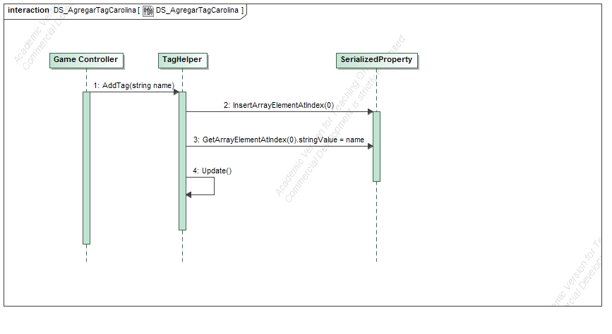
- DS_AgregarTagCarolina
Messages

No. | Message Name | Sender | Receiver | Constraints
1 | AddTag(string name) | Game Controller : | TagHelper :
2 | InsertArrayElementAtIndex(0) | TagHelper : | SerializedProperty :
3 | GetArrayElementAtIndex(0).stringValue = name | TagHelper : | SerializedProperty :
4 | Update() | TagHelper : | TagHelper :

DS_ChopTree_María Diagram

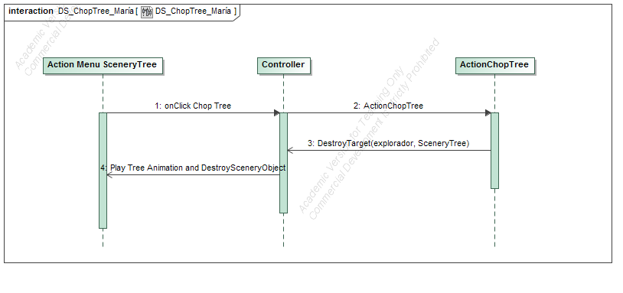
- DS_ChopTree_María
Messages

No. | Message Name | Sender | Receiver | Constraints
1 | onClick Chop Tree | Action Menu SceneryTree : | Controller :
2 | ActionChopTree | Controller : | ActionChopTree :
3 | DestroyTarget(explorador, SceneryTree) | ActionChopTree : | Controller :
4 | Play Tree Animation and DestroySceneryObject | Controller : | Action Menu SceneryTree :

DS_Cientfico_AccionAnalizarPH_Paolo Diagram

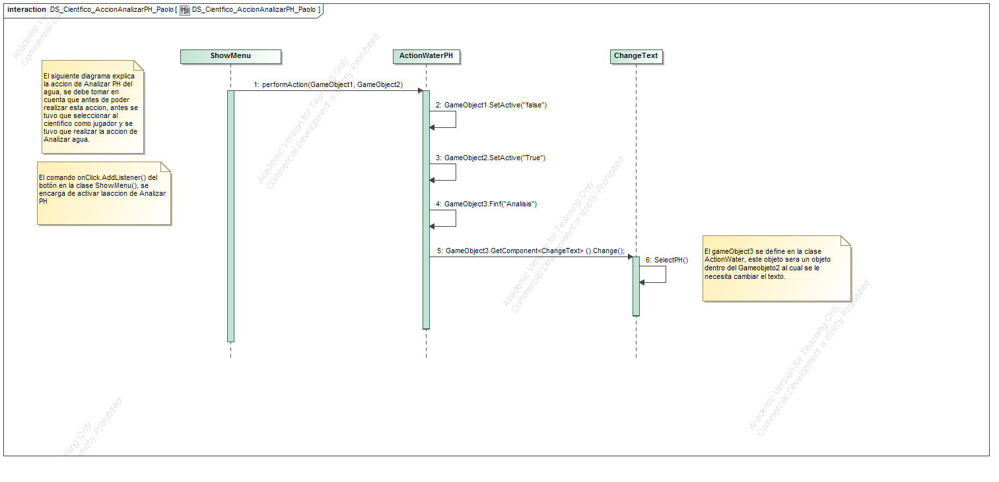
- DS_Cientfico_AccionAnalizarPH_Paolo
Messages

No. | Message Name | Sender | Receiver | Constraints
1 | performAction(GameObject1, GameObject2) | ShowMenu : | ActionWaterPH :
2 | GameObject1.SetActive("false") | ActionWaterPH : | ActionWaterPH :
3 | GameObject2.SetActive("True") | ActionWaterPH : | ActionWaterPH :
4 | GameObject3.Finf("Analisis") | ActionWaterPH : | ActionWaterPH :
5 | GameObject3.GetComponent<ChangeText> ().Change(); | ActionWaterPH : | ChangeText :
6 | SelectPH() | ChangeText : | ChangeText :

DS_CreateRoad_Carolina Diagram

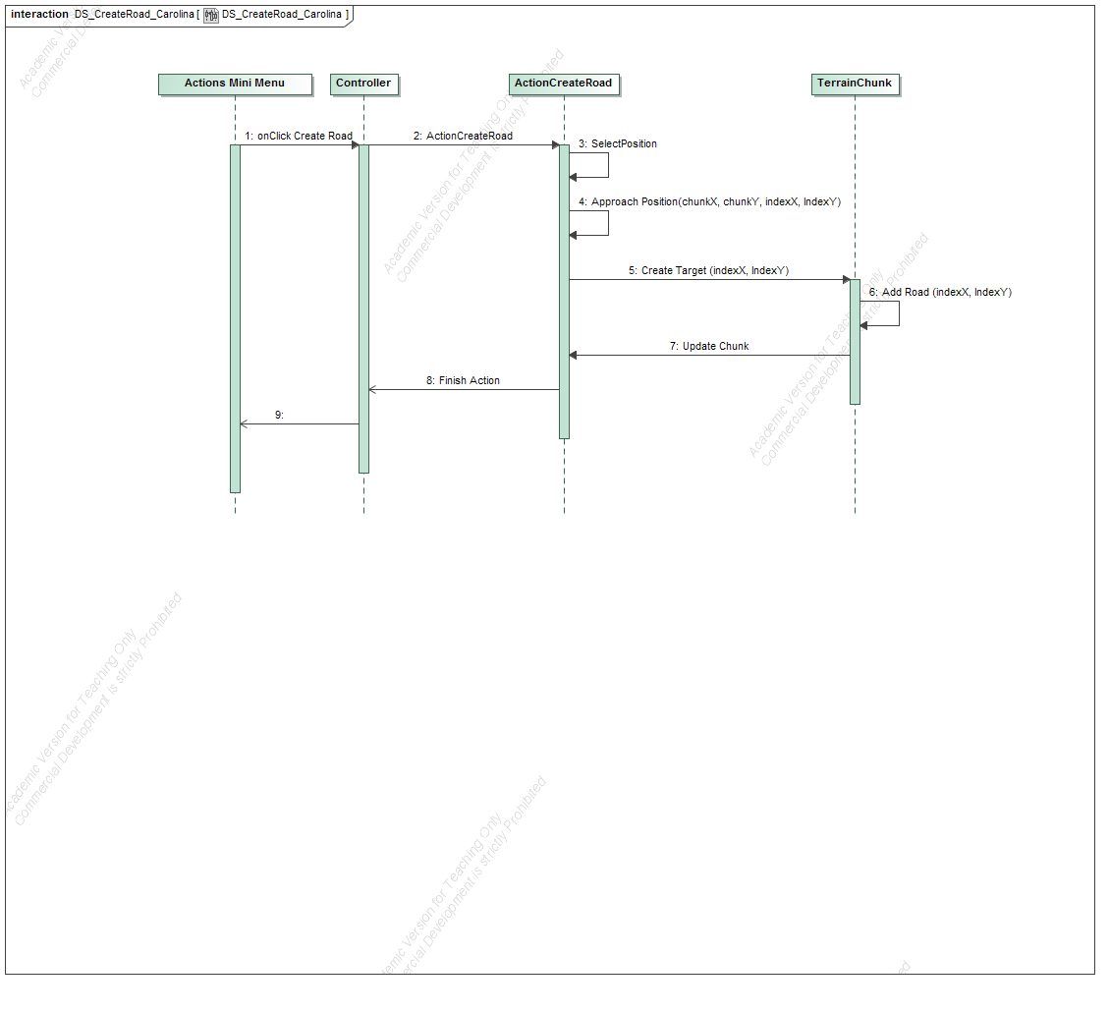
- DS_CreateRoad_Carolina
Messages

No. | Message Name | Sender | Receiver | Constraints
1 | onClick Create Road | Actions Mini Menu : | Controller :
2 | ActionCreateRoad | Controller : | ActionCreateRoad :
3 | SelectPosition | ActionCreateRoad : | ActionCreateRoad :
4 | Approach Position(chunkX, chunkY, indexX, IndexY) | ActionCreateRoad : | ActionCreateRoad :
5 | Create Target (indexX, IndexY) | ActionCreateRoad : | TerrainChunk :
6 | Add Road (indexX, IndexY) | TerrainChunk : | TerrainChunk :
7 | Update Chunk | TerrainChunk : | ActionCreateRoad :
8 | Finish Action | ActionCreateRoad : | Controller :
9 |  | Controller : | Actions Mini Menu :

DS_InteraccionPinza_JJ Diagram

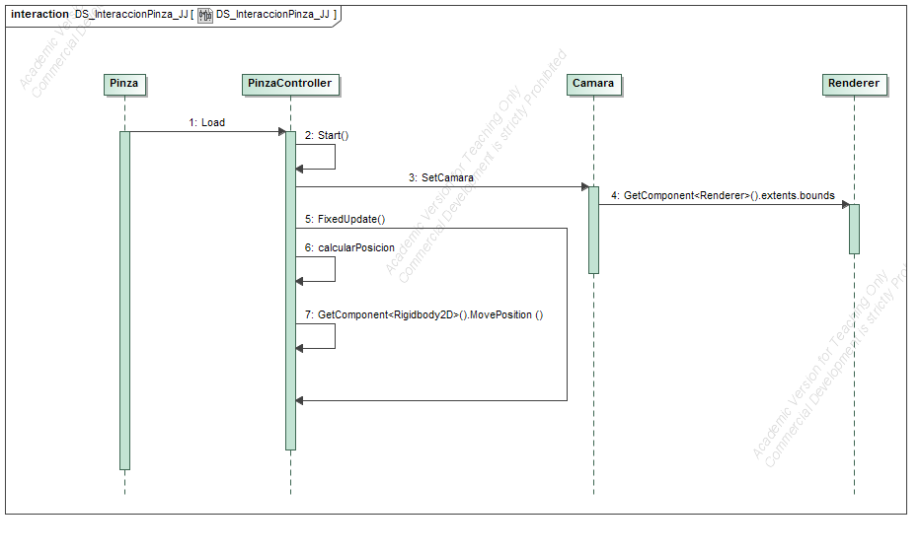
- DS_InteraccionPinza_JJ
Messages

No. | Message Name | Sender | Receiver | Constraints
1 | Load | Pinza : | PinzaController :
2 | Start() | PinzaController : | PinzaController :
3 | SetCamara | PinzaController : | Camara :
4 | GetComponent<Renderer>().extents.bounds | Camara : | Renderer :
5 | FixedUpdate() | PinzaController : | PinzaController :
6 | calcularPosicion | PinzaController : | PinzaController :
7 | GetComponent<Rigidbody2D>().MovePosition () | PinzaController : | PinzaController :

DS_Laboratory_Paolo Diagram

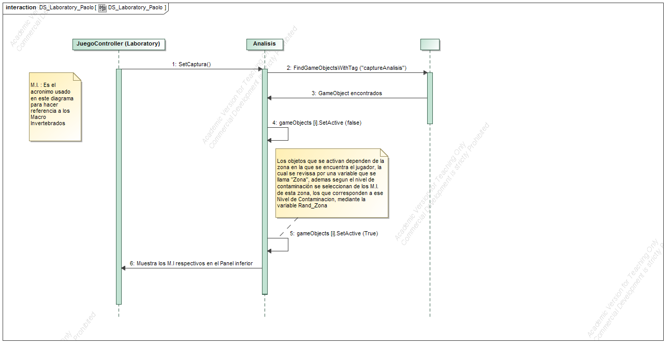
- DS_Laboratory_Paolo
Messages

No. | Message Name | Sender | Receiver | Constraints
1 | SetCaptura() | JuegoController (Laboratory) : | Analisis :
2 | FindGameObjectsWithTag ("captureAnalisis") | Analisis : | :
3 | GameObject encontrados | : | Analisis :
4 | gameObjects [i].SetActive (false) | Analisis : | Analisis :
5 | gameObjects [i].SetActive (True) | Analisis : | Analisis :
6 | Muestra los M.I respectivos en el Panel inferior | Analisis : | JuegoController (Laboratory) :

DS_MemoryGame_María Diagram

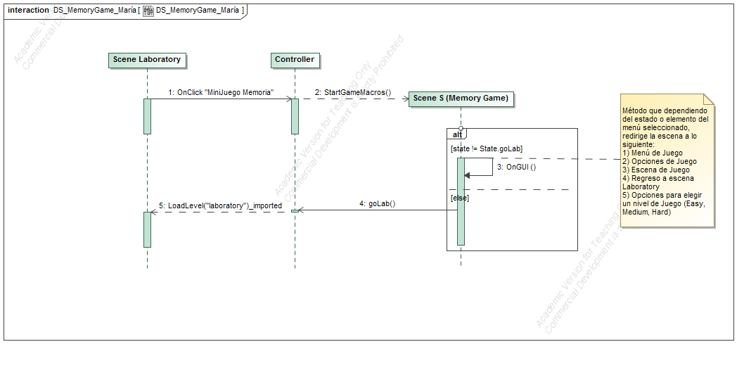
- DS_MemoryGame_María
Messages

No. | Message Name | Sender | Receiver | Constraints
1 | OnClick "MiniJuego Memoria" | Scene Laboratory : | Controller :
2 | StartGameMacros() | Controller : | Scene S (Memory Game) :
3 | OnGUI () | Scene S (Memory Game) : | Scene S (Memory Game) :
4 | goLab() | Scene S (Memory Game) : | Controller :
5 | LoadLevel("laboratory")_imported | Controller : | Scene Laboratory :

DS_Menu_Michelle Diagram

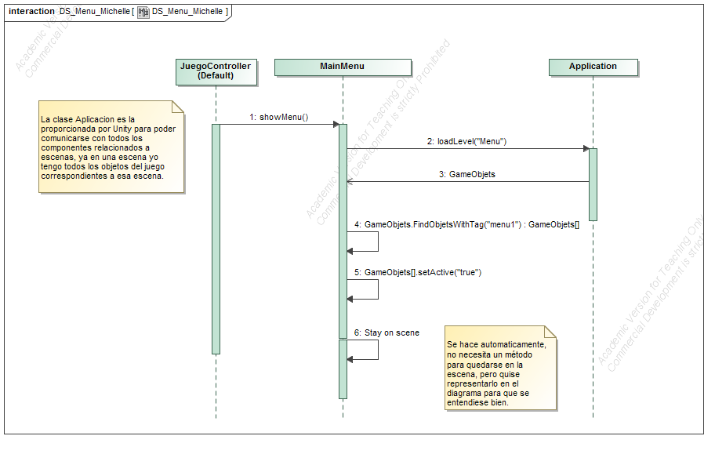
- DS_Menu_Michelle
Messages

No. | Message Name | Sender | Receiver | Constraints
1 | showMenu() | JuegoController  (Default) : | MainMenu :
2 | loadLevel("Menu") | MainMenu : | Application :
3 | GameObjets | Application : | MainMenu :
4 | GameObjets.FindObjetsWithTag("menu1") : GameObjets[] | MainMenu : | MainMenu :
5 | GameObjets[].setActive("true") | MainMenu : | MainMenu :
6 | Stay on scene | MainMenu : | MainMenu :

DS_MiniJuegoTrashCollectionJJ Diagram

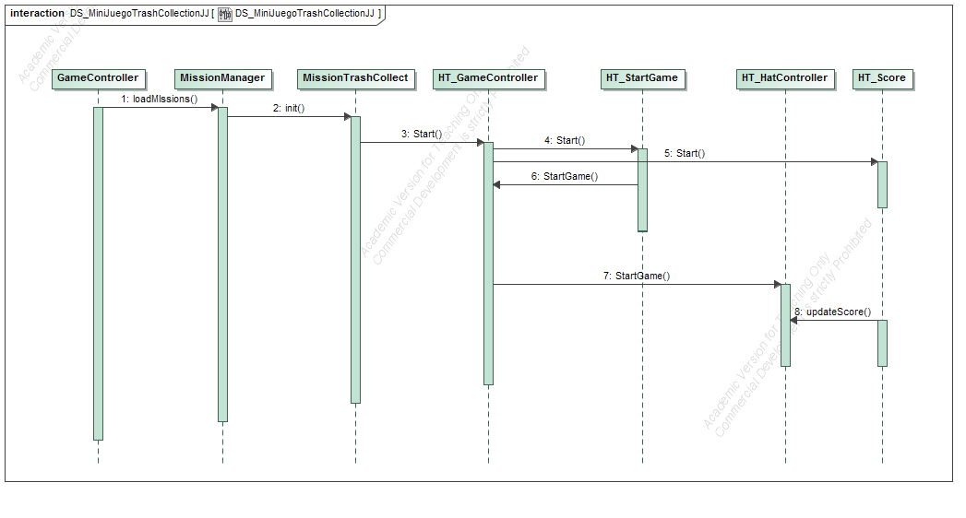
- DS_MiniJuegoTrashCollectionJJ
Messages

No. | Message Name | Sender | Receiver | Constraints
1 | loadMIssions() | GameController : | MissionManager :
2 | init() | MissionManager : | MissionTrashCollect :
3 | Start() | MissionTrashCollect : | HT_GameController :
4 | Start() | HT_GameController : | HT_StartGame :
5 | Start() | HT_GameController : | HT_Score :
6 | StartGame() | HT_StartGame : | HT_GameController :
7 | StartGame() | HT_GameController : | HT_HatController :
8 | updateScore() | HT_Score : | HT_HatController :

DS_MisionConstruirPuenteMichelle Diagram

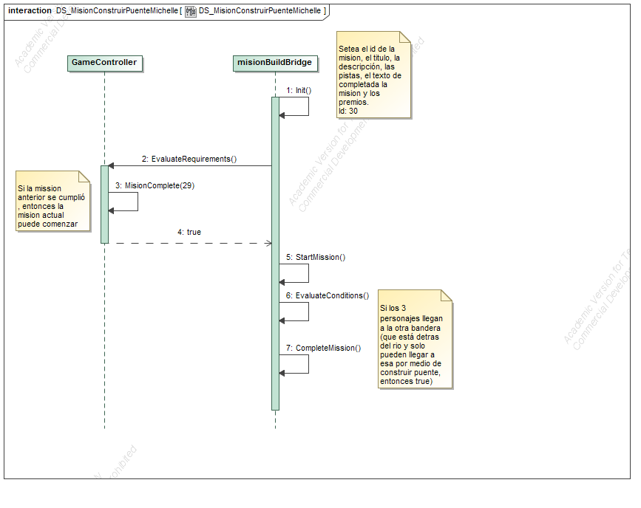
- DS_MisionConstruirPuenteMichelle
Messages

No. | Message Name | Sender | Receiver | Constraints
1 | Init() | misionBuildBridge : | misionBuildBridge :
2 | EvaluateRequirements() | misionBuildBridge : | GameController :
3 | MisionComplete(29) | GameController : | GameController :
4 | true | GameController : | misionBuildBridge :
5 | StartMission() | misionBuildBridge : | misionBuildBridge :
6 | EvaluateConditions() | misionBuildBridge : | misionBuildBridge :
7 | CompleteMission() | misionBuildBridge : | misionBuildBridge :

DS_PuntosEcologicos_Cortar_Andres Diagram

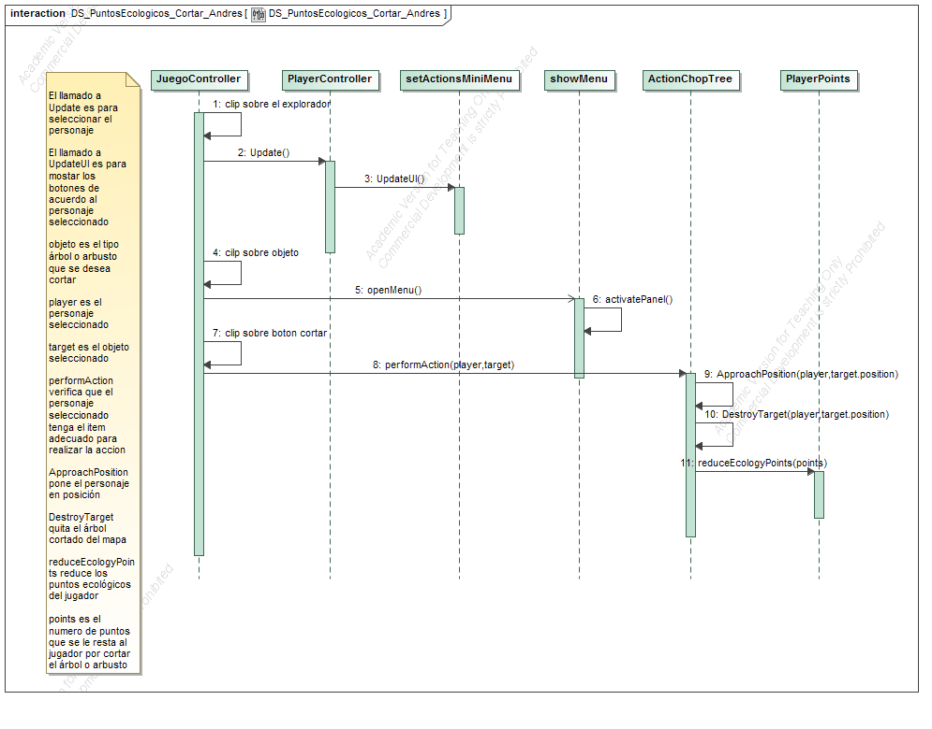
- DS_PuntosEcologicos_Cortar_Andres
Messages

No. | Message Name | Sender | Receiver | Constraints
1 | clip sobre el explorador | JuegoController : | JuegoController :
2 | Update() | JuegoController : | PlayerController :
3 | UpdateUI() | PlayerController : | setActionsMiniMenu :
4 | cilp sobre objeto | JuegoController : | JuegoController :
5 | openMenu() | JuegoController : | showMenu :
6 | activatePanel() | showMenu : | showMenu :
7 | clip sobre boton cortar | JuegoController : | JuegoController :
8 | performAction(player,target) | JuegoController : | ActionChopTree :
9 | ApproachPosition(player,target.position) | ActionChopTree : | ActionChopTree :
10 | DestroyTarget(player,target.position) | ActionChopTree : | ActionChopTree :
11 | reduceEcologyPoints(points) | ActionChopTree : | PlayerPoints :

DS_PuntosEcologicos_Sembrar_Andres Diagram

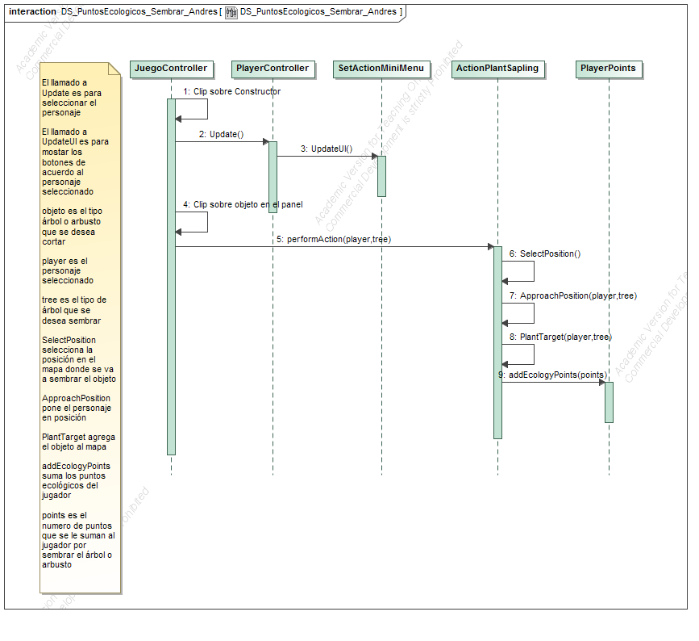
- DS_PuntosEcologicos_Sembrar_Andres
Messages

No. | Message Name | Sender | Receiver | Constraints
1 | Clip sobre Constructor | JuegoController : | JuegoController :
2 | Update() | JuegoController : | PlayerController :
3 | UpdateUI() | PlayerController : | SetActionMiniMenu :
4 | Clip sobre objeto en el panel | JuegoController : | JuegoController :
5 | performAction(player,tree) | JuegoController : | ActionPlantSapling :
6 | SelectPosition() | ActionPlantSapling : | ActionPlantSapling :
7 | ApproachPosition(player,tree) | ActionPlantSapling : | ActionPlantSapling :
8 | PlantTarget(player,tree) | ActionPlantSapling : | ActionPlantSapling :
9 | addEcologyPoints(points) | ActionPlantSapling : | PlayerPoints :

DS_TrashCrushAndres Diagram

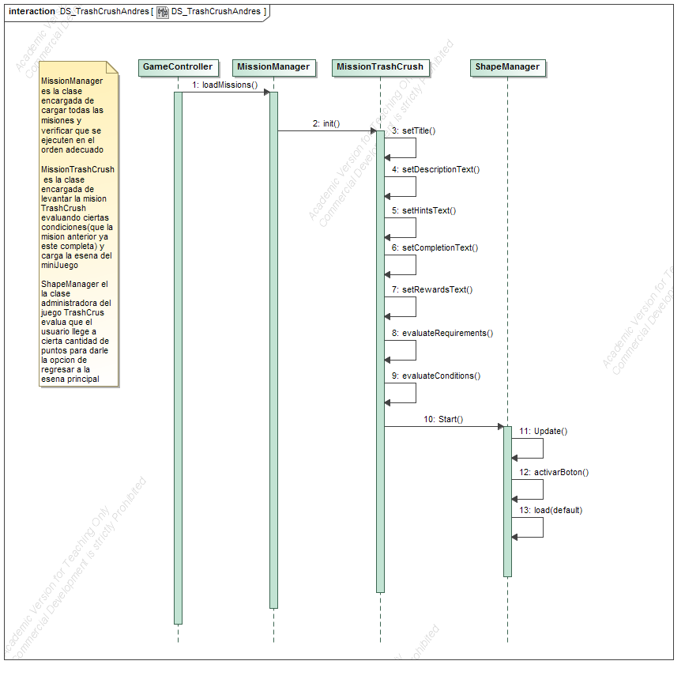
- DS_TrashCrushAndres
Messages

No. | Message Name | Sender | Receiver | Constraints
1 | loadMissions() | GameController : | MissionManager :
2 | init() | MissionManager : | MissionTrashCrush :
3 | setTitle() | MissionTrashCrush : | MissionTrashCrush :
4 | setDescriptionText() | MissionTrashCrush : | MissionTrashCrush :
5 | setHintsText() | MissionTrashCrush : | MissionTrashCrush :
6 | setCompletionText() | MissionTrashCrush : | MissionTrashCrush :
7 | setRewardsText() | MissionTrashCrush : | MissionTrashCrush :
8 | evaluateRequirements() | MissionTrashCrush : | MissionTrashCrush :
9 | evaluateConditions() | MissionTrashCrush : | MissionTrashCrush :
10 | Start() | MissionTrashCrush : | ShapeManager :
11 | Update() | ShapeManager : | ShapeManager :
12 | activarBoton() | ShapeManager : | ShapeManager :
13 | load(default) | ShapeManager : | ShapeManager :

DS_Zonas_Michelle Diagram

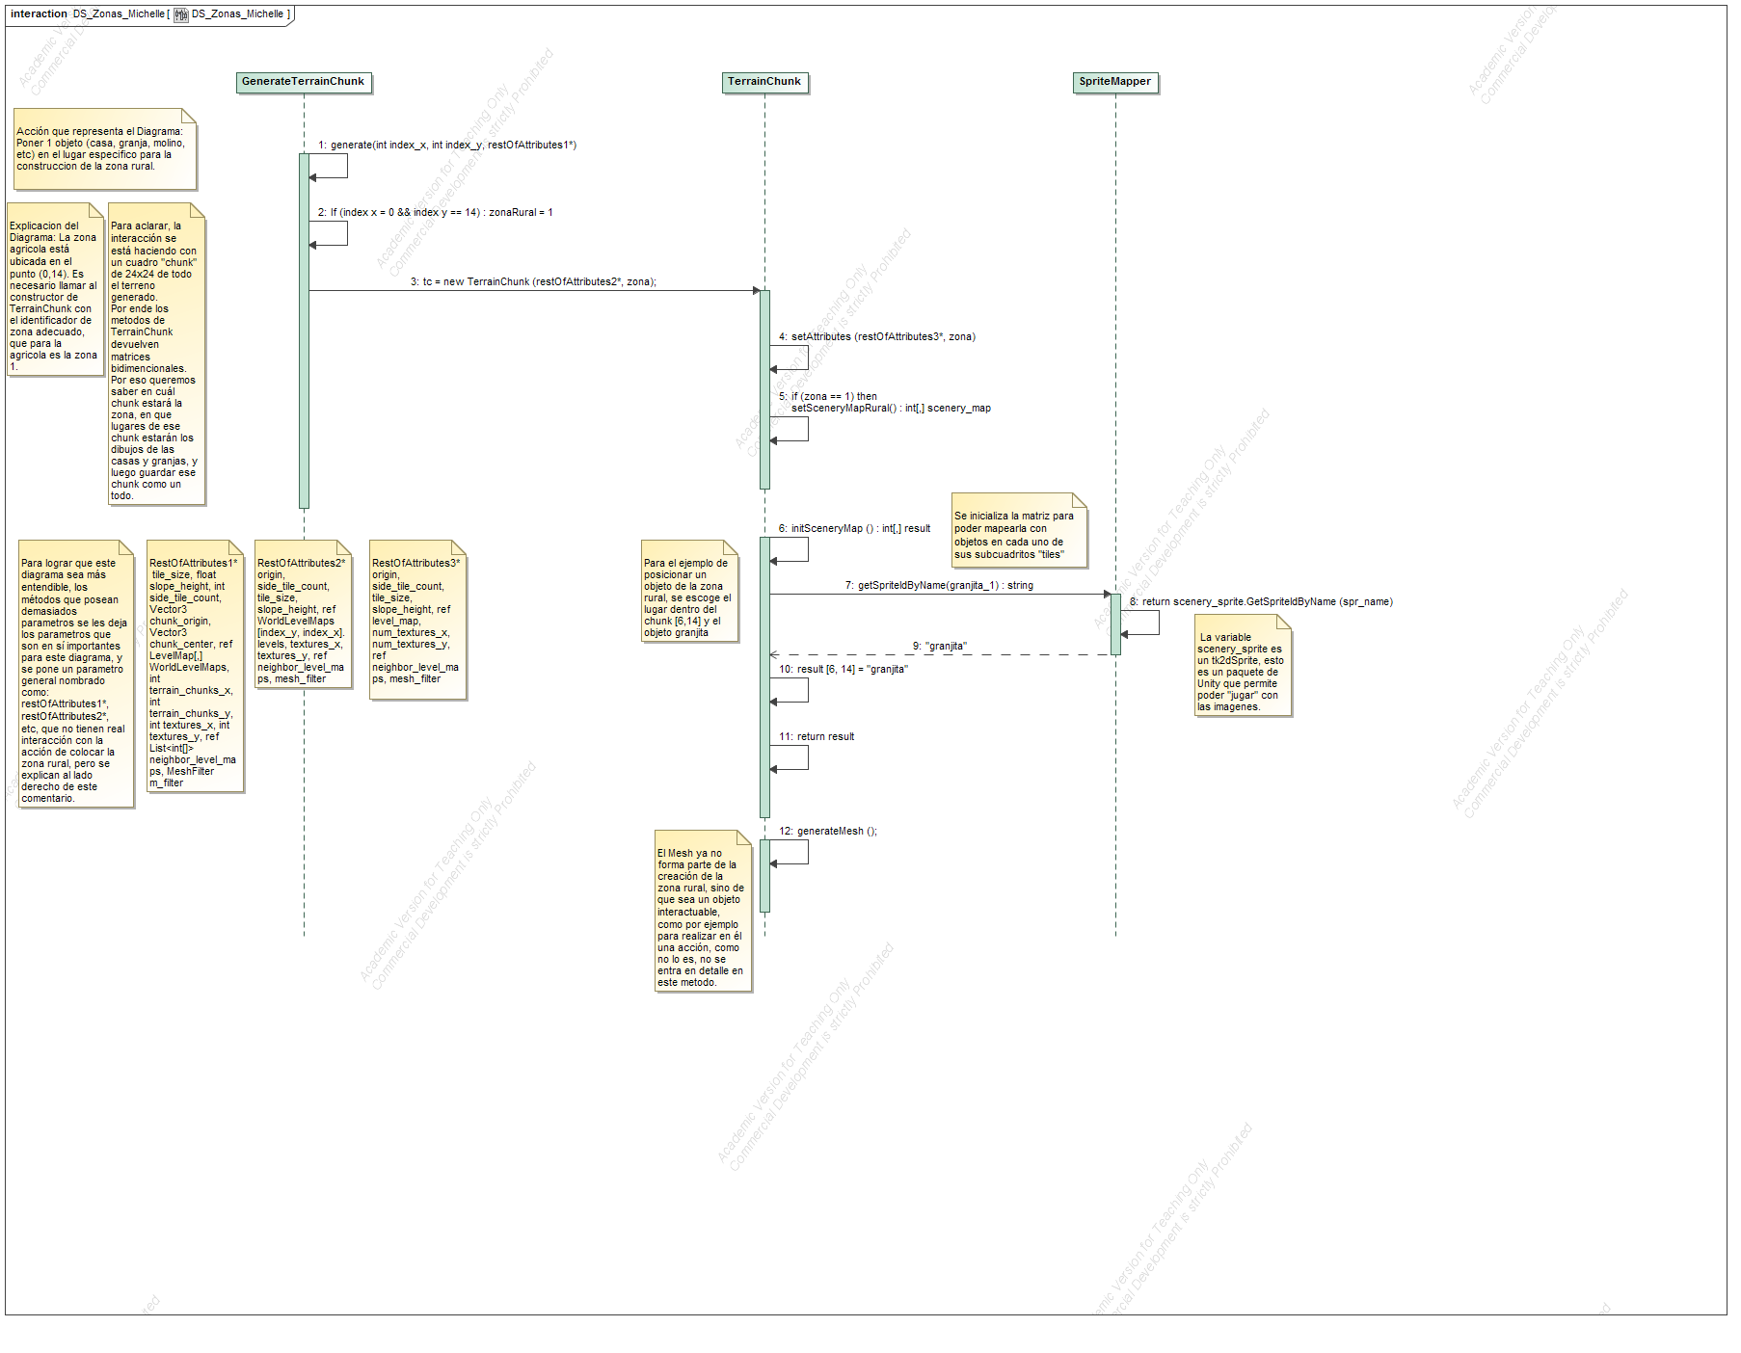
- DS_Zonas_Michelle
Messages

No. | Message Name | Sender | Receiver | Constraints
1 | generate(int index_x, int index_y, restOfAttributes1*) | GenerateTerrainChunk : | GenerateTerrainChunk :
2 | If (index x = 0 && index y == 14) : zonaRural = 1 | GenerateTerrainChunk : | GenerateTerrainChunk :
3 | tc = new TerrainChunk (restOfAttributes2*, zona); | GenerateTerrainChunk : | TerrainChunk :
4 | setAttributes (restOfAttributes3*, zona) | TerrainChunk : | TerrainChunk :
5 | if (zona == 1) then  setSceneryMapRural() : int[,] scenery_map | TerrainChunk : | TerrainChunk :
6 | initSceneryMap () : int[,] result | TerrainChunk : | TerrainChunk :
7 | getSpriteIdByName(granjita_1) : string | TerrainChunk : | SpriteMapper :
8 | return scenery_sprite.GetSpriteIdByName (spr_name) | SpriteMapper : | SpriteMapper :
9 | "granjita" | SpriteMapper : | TerrainChunk :
10 | result [6, 14] = "granjita" | TerrainChunk : | TerrainChunk :
11 | return result | TerrainChunk : | TerrainChunk :
12 | generateMesh (); | TerrainChunk : | TerrainChunk :

